System Design Document Template

Ketlheen Silva

Southern New Hampshire University

CS-255 System Analysis and Design

Aline Yurik

October 17, 2026

CS 255 System Design Document Template

UML Diagrams

UML Use Case Diagram
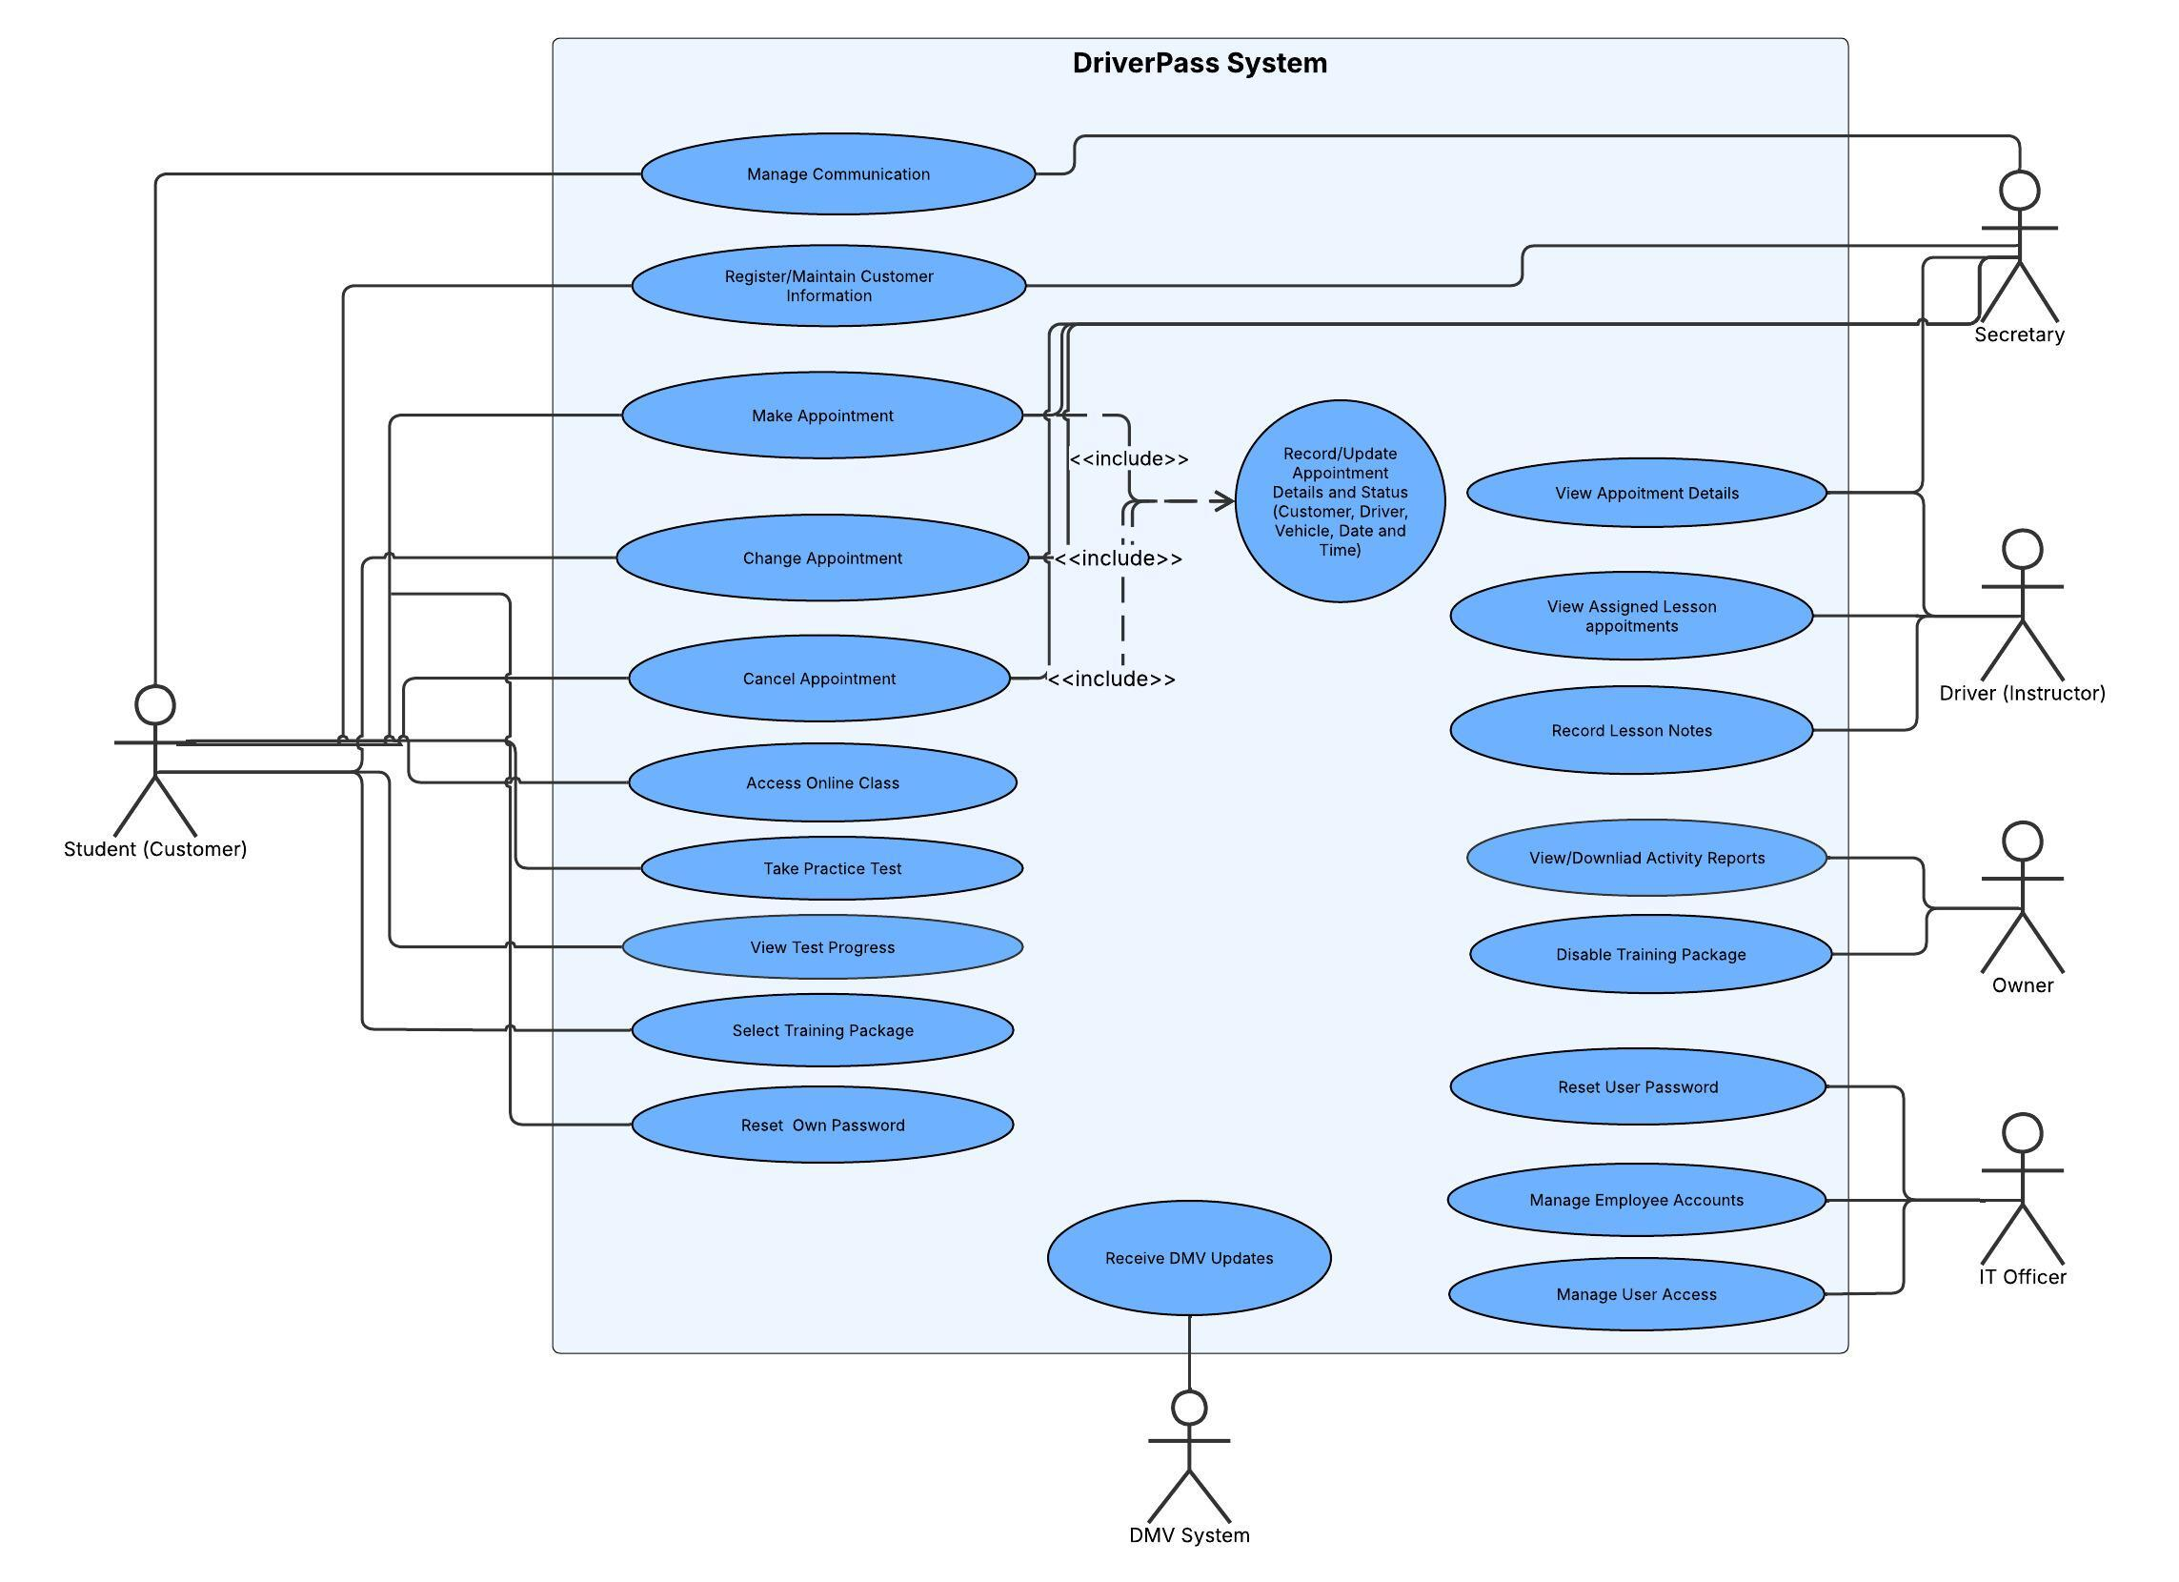

UML Activity Diagrams
Activity 1: Instructor calls out, and the secretary arranges rescheduling of the appointment.
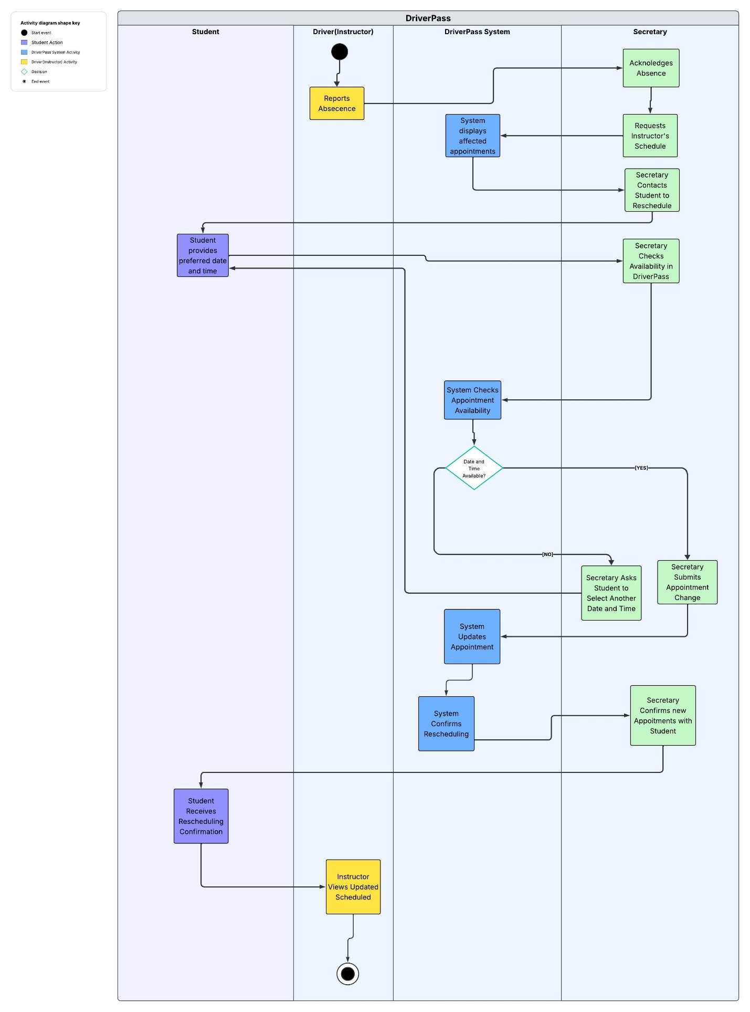
Activity 2: Student books an appointment
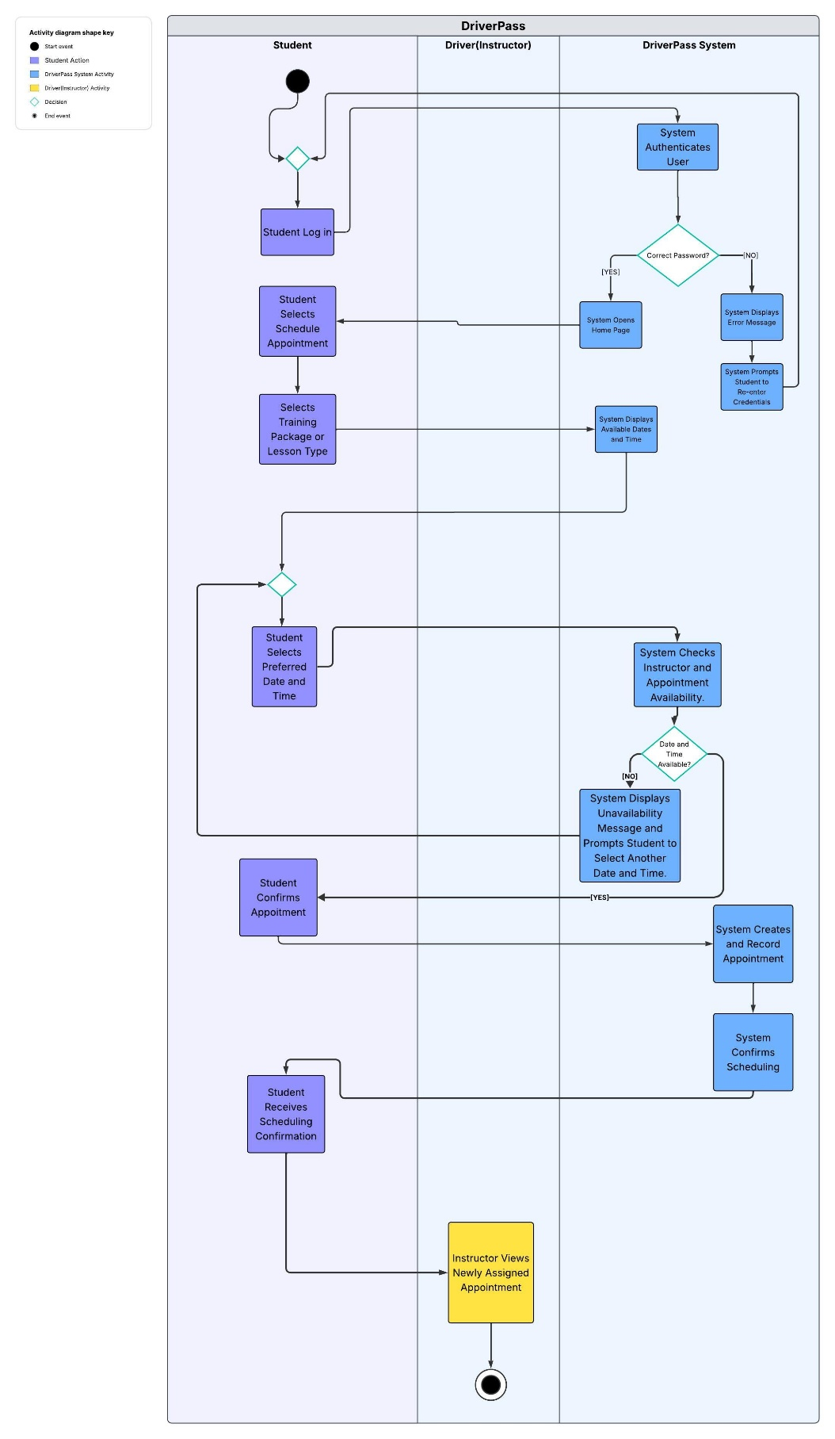

UML Sequence Diagram
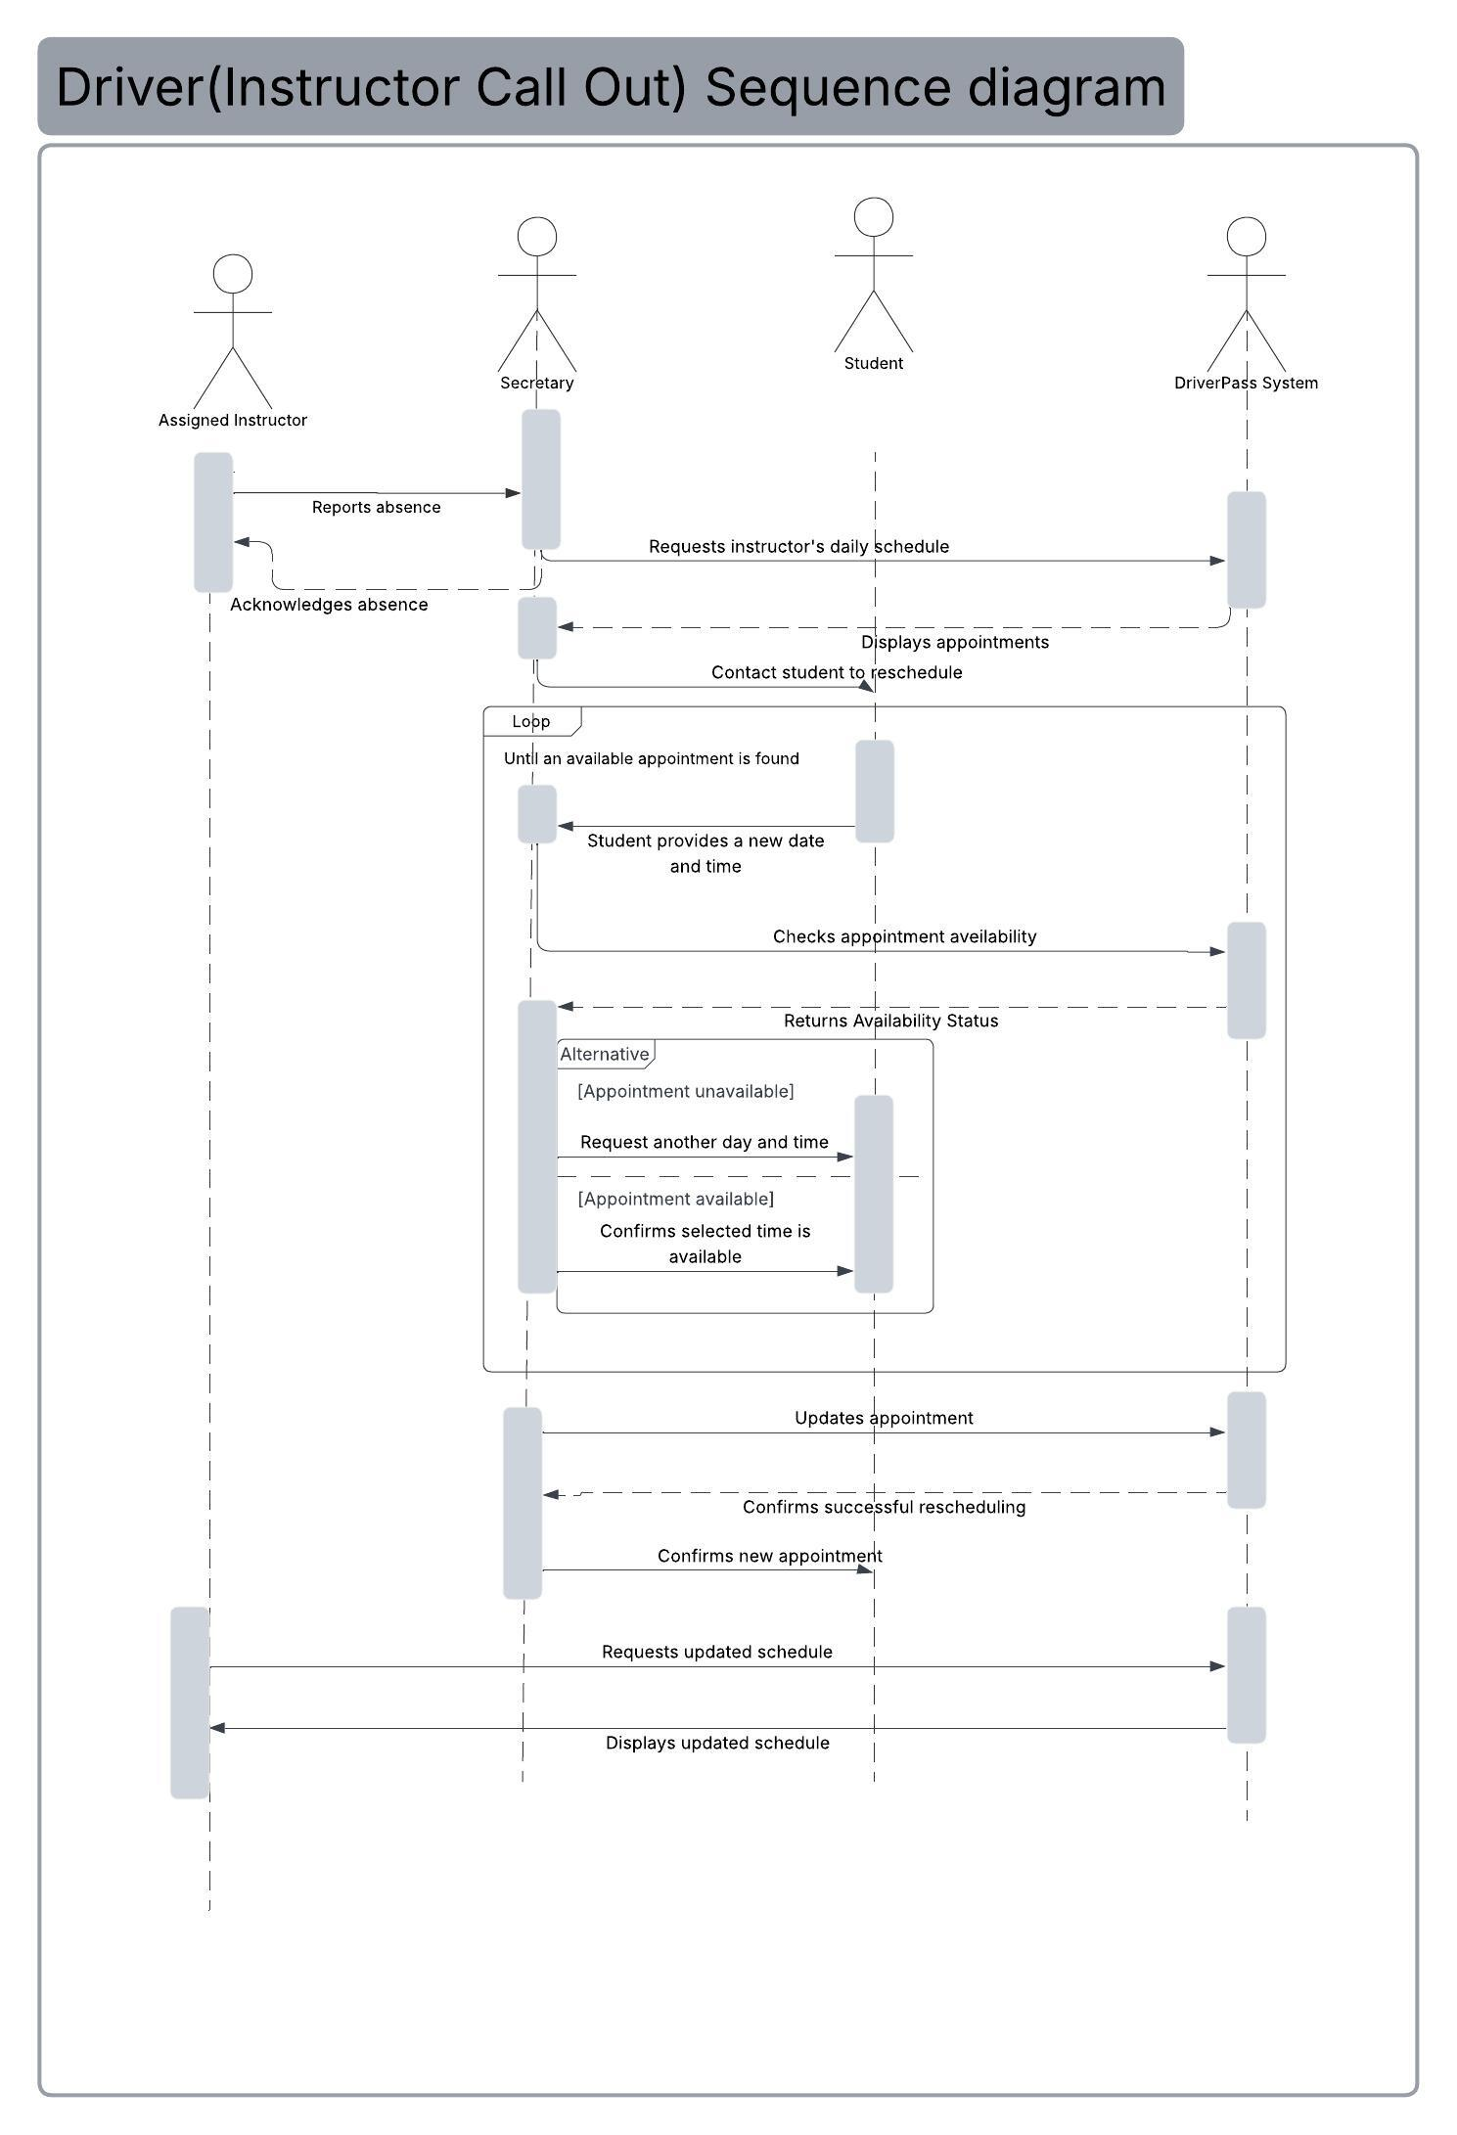

UML Class Diagram
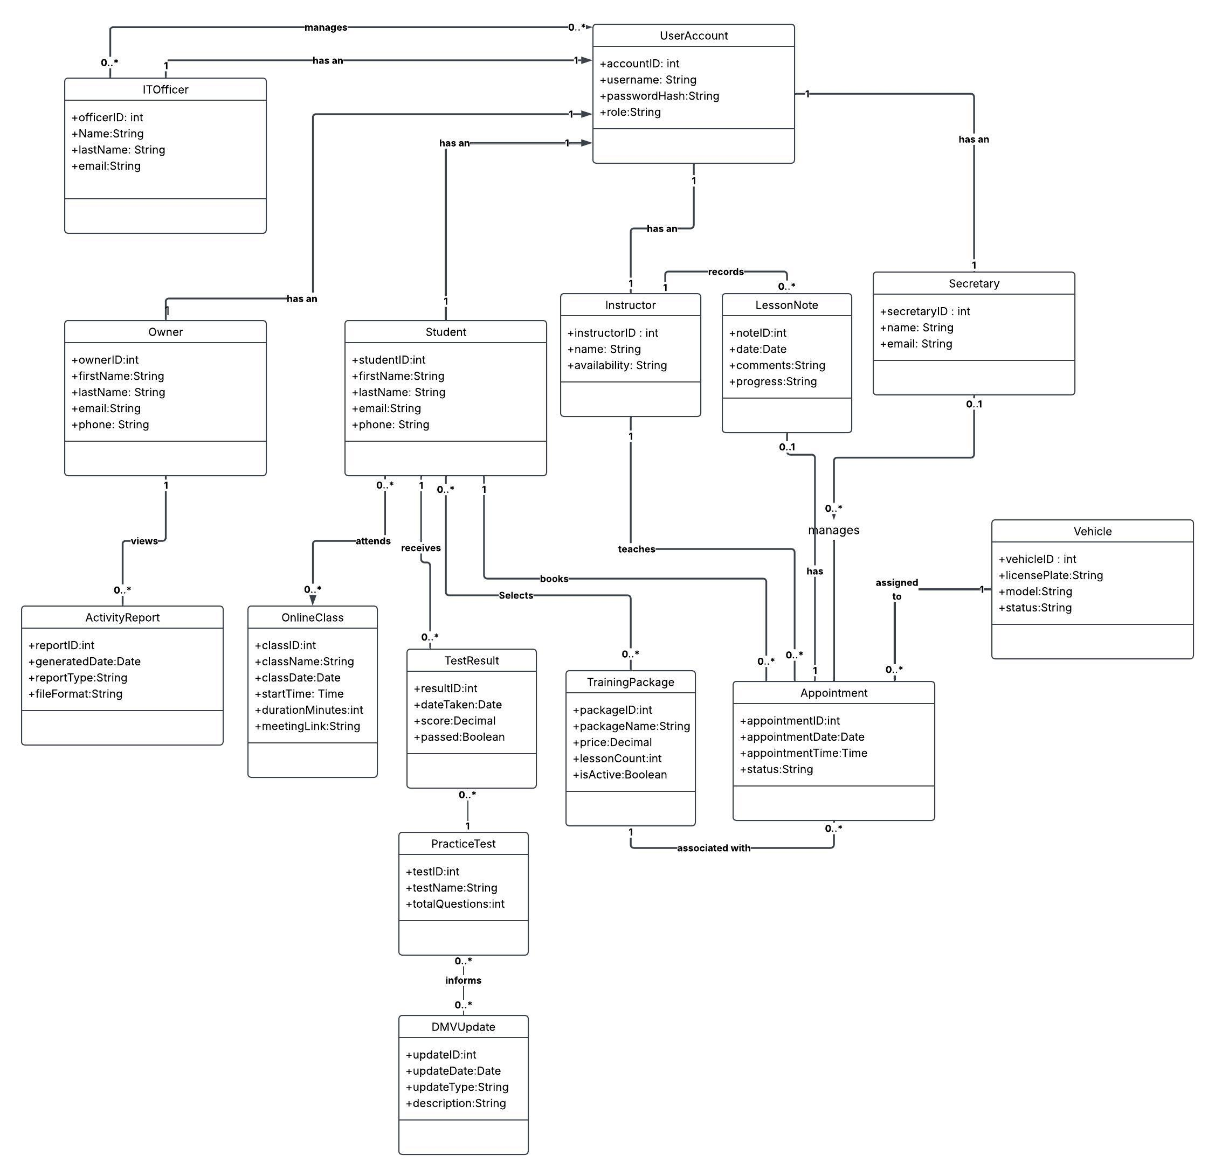

Technical Requirements
The DriverPass system will be a web-based application that allows customers and employees to access its services from computers and mobile devices. The system will preferably use cloud hosting so DriverPass does not have to maintain its own servers. To support the different features of the system, certain hardware, software, tools, and infrastructure will be needed.
Hardware Requirements
The system will require computers for employees such as the secretary, owner, and IT officer to manage customer information, appointments, reports, and user accounts. Instructors will need computers or mobile devices to check their schedules and record lesson notes. Customers will also need access to a computer, tablet, or smartphone with an internet connection to schedule appointments, take practice tests, and access online classes.
Software Requirements
The system will need a web application that works on different browsers and devices. A database will also be required to store customer information, appointments, training packages, instructor schedules, practice-test results, and lesson notes. The database should keep records of who creates, changes, or cancels appointments so DriverPass can generate activity reports.
The system will also need a login feature that provides different levels of access depending on the user's role. For example, customers will be able to schedule and manage appointments, instructors will be able to view their schedules and add lesson notes, and the IT officer will be able to manage employee accounts and reset passwords.
Tools and Development Requirements
Development tools will be needed to build, test, and maintain the DriverPass system. Lucidchart can be used to create UML diagrams that help explain how the system works and how its different components are connected. Programming and database management tools will also be needed to develop the application and manage the information stored in the system.
Testing tools will be important to make sure that the different features work correctly. For example, the appointment scheduling feature should be tested to confirm that available dates and times are displayed correctly and that two students cannot book the same instructor for the same time. The system should also be tested to make sure users can only access information based on their assigned roles.
Infrastructure and Security Requirements
DriverPass will need a reliable internet connection and a cloud hosting service to allow customers and employees to access the system. The cloud service should provide data storage, backups, and security to help protect customer and business information.
The system should use secure connections to protect information shared between users and the website. Passwords and personal information should also be protected to prevent unauthorized access. The system will need to support updates from the DMV so that training materials and practice questions remain current.
Users should also be able to download reports and other information to view offline, including files that can be opened in Microsoft Excel. However, any changes to appointments or customer information will need to be made while connected to the internet to prevent duplicate or conflicting records.
Overall, these technical requirements will help DriverPass provide a system that is accessible, secure, and easy to use while supporting the different needs of customers and employees.

